**Project Design Phase-II**

**Technology Stack (Architecture & Stack)**

|  |  |
| --- | --- |
| **Team ID** | **PNT2022TMID23950** |
| **Project Name** | **University Admit Eligibility Predictor** |

**Technical Architecture:**

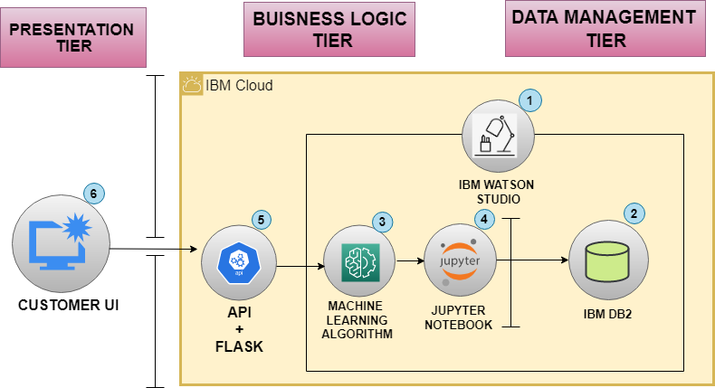

**Guidelines:**

1. **Create a Watson Studio Project on IBM Cloud.**
2. **IBM DB2 on Cloud Database stores information that will be used for machine learning and predictions.**
3. **Watson Machine Learning helps to create ML models so that new predictions can be run against the model.**
4. **Jupyter notebook uses DB2 on Cloud and Watson Machine Learning to create the machine learning model.**
5. **The model is exposed through API and Flask.**
6. **Customer UI uses the API to send new data for predictions.**

**Table-1: Components & Technologies**

|  |  |  |  |
| --- | --- | --- | --- |
| **S. No** | **Component** | **Description** | **Technology** |
|  | User Interface | * Registration through Form, Gmail, Facebook * Confirmation via Mail * Login and Logout via Mail and Password | HTML, CSS, JavaScript |
|  | Platform | * Platform for coding purpose | Jupyter notebook |
|  | Data pre-processing | * Removing noisy values in the Dataset * Handling Missing Values | Python libraries (pandas, NumPy, Scikit-learn) |
|  | Data visualization | * Graphical representation of student details like chart, graph, plots, etc for easy understanding. | Matplotlib, Seaborn |
|  | Database | * Storing Student details | IBM DB2 |
|  | Cloud Database | * Database Service on Cloud | IBM DB2, IBM Watson cloud |
|  | Machine Learning Algorithms | * Purpose of Machine Learning Model | Linear & Logistic Regressions, SVM, Naïve Bayes, Decision tree |
|  | Infrastructure (Server / Cloud) | * Cloud server configuration for hosting the website. | IBM cloud |

**Table-2: Application Characteristics:**

| **S. No** | **Characteristics** | **Description** | **Technology** |
| --- | --- | --- | --- |
|  | Open-Source Frameworks | * To connect front end and backend. | Flask python |
|  | Security Implementations | * Confidentiality * Integrity * Availability * Updated Software and APIs | Firewall, SSL certification, Encryptions, IAM Controls, Recommending strong passwords, etc |
|  | Scalable Architecture | * Use of cloud features like resource provisioning in all the 3-tiers | IBM Cloud |
|  | Availability | * Ensuring anytime and anywhere * Load balancing * Traffic management | IBM Load balancing |
|  | Performance | * Simple and modular website with fast loading (<5sec) * Moderate page size of html, CSS, JavaScript files * Fully compressed and optimized images and videos | CDN |